BUILDING AN APPLICATION THAT WILL STORE USER PHOTOS AND GALLERIES.



Contents

Database Models 2

Methods 3

login 3

logout 3

home 3

gallery 4

galleryhome 4

deletegallery 4

imagedelete 5

# Database Models

Following is the ER Diagram showing Tables that are created in database to store the data related to photo Gallery.

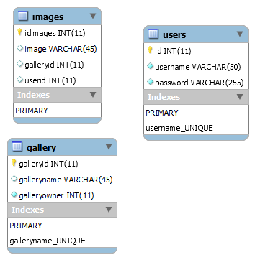

‘users’ table contains primary key ‘id’, username and password. Where unique index is applied at username. A user can have many galleries. So In gallery table ‘galleryowner’ represents userid to which the gallery belongs. While images table stores data about individual images. It contains userid and galleryid to which an image belongs.

# Methods

Following methods are created to implement the functionality

## login

Login method implements login user registration functionality. Login methods checks in database if a username already exists and then it verifies the password. If password matches, the user is logged in else a new user is created and newly created user is logged in.



## logout

logout method simply removes session variables and redirects user to login page.

## home

Home method renders ‘home’ view. And it lists all Photo Galleries that belong to logged in user. If user is not logged in, it’s redirected to login page.

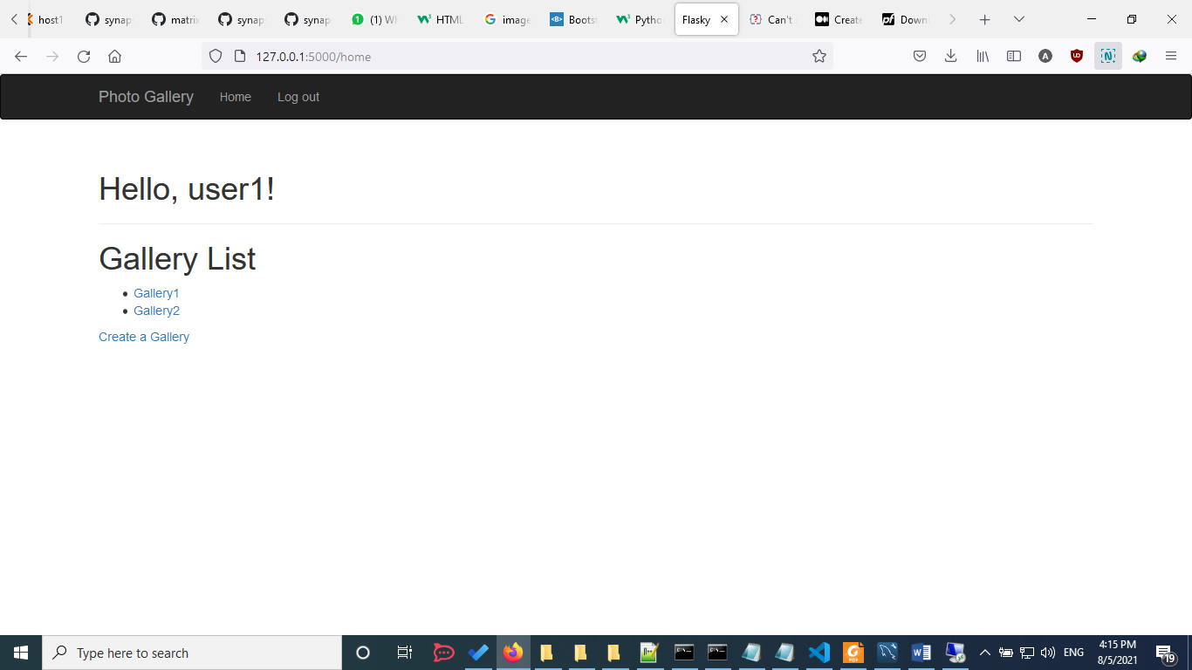

## gallery

This method is used to add a new gallery. It renders ‘gallery’ view and a form is displayed to add a new gallery to logged in user. It also handles form data to store gallery in database table.

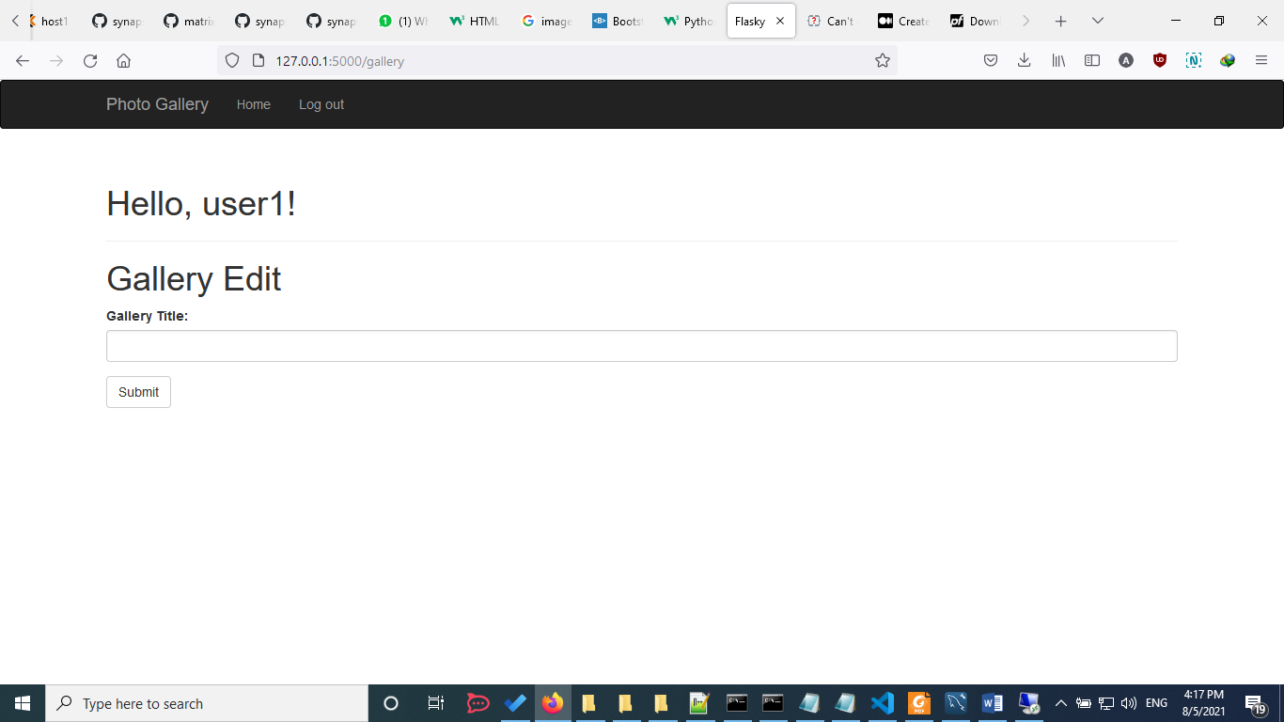

## galleryhome

Gallery Home method shows all images that are contained in a gallery. It also handles form data to upload a new image and store image data in database. It finally renders “galleryhome” view to list all images in grid form.

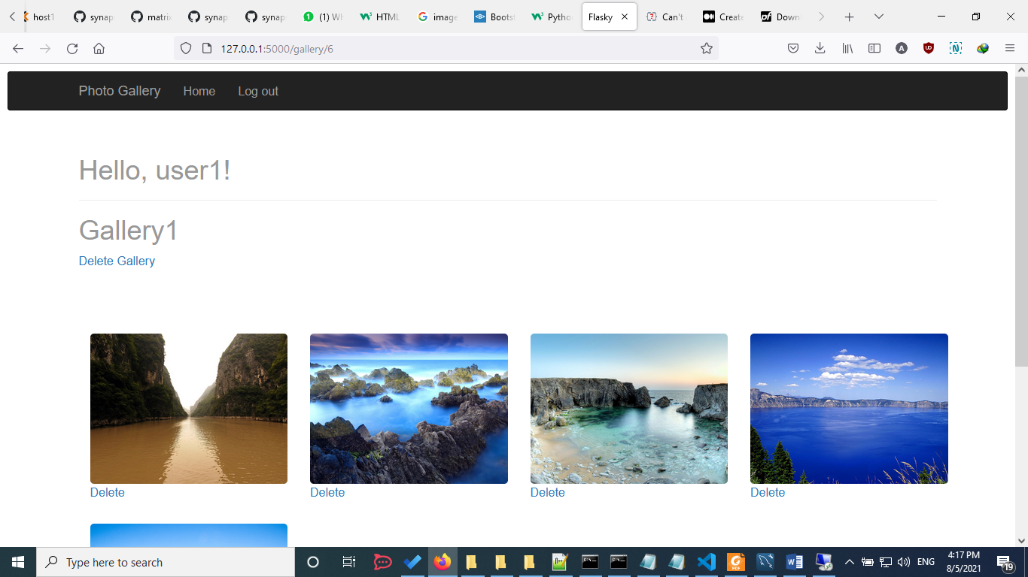

## deletegallery

Delete Gallery method checks if the gallery is empty by counting images contained in the gallery. And if the gallery is empty it removes it from database. If gallery is not empty it does not delete it.

## imagedelete

Image delete method deletes an image from file system and also from the database.